Product Specifications Effective Date: May 25, 2018
Product Name: White Chocolate Gift Box
Product Code: 8551
GTIN: 10778463085519
Origin: Made in Canada from Domestic and Imported Ingredients
-------------------------------------------------------------------------------------------------------------------------------
Product Description: An overlapping of vanilla cream and smooth vanilla cake, coated with crunchy white chocolate, finished with decor.

Weight:
Net Individual: 55 g / 2 oz
Net Case: 1.54 kg / 3 lb 6 oz

Packaging:
Each case has 28 units.
Case Dimensions: 8.3” x 29.0” x 41.5”

Ti/Hi: 15/9

Ingredients: Cake mix (sugar, enriched flour, whey, leavening, modified corn starch, vegetable oil (canola and/or soya), salt, natural flavour, cellulosic gum), Soybean oil and palm/palm kernel oil margarine, White chocolate (sugar, cocoa butter, milk ingredients, soy lecithin, vanilla extract ), Water, Whole egg, Canola oil, Dark chocolate (sugar, cocoa paste, cocoa butter, soya lecithin, vanilla aroma), Coconut oil, Green chocolate (sugar, hydrogenated palm kernel and cotton oil, milk substance, lactylated fatty acid esters of glycerol , food coloring, soya lecithin, artificial aroma), Natural vanilla essence (water, ethyl alcohol, vanilla bean extract), Coloring (water, propylene glycol, orange-yellow S).
Contains: Wheat, Milk, Eggs, Soy, Coconut.
Ingrédients: Mélange à gâteau (sucre, farine de blé, substances laitières modifiées, levure chimique, amidon de maïs modifié, huile végétale (canola et/ou soya), sel, arômes naturelles, gomme cellulosique), Margarine à l’huile de soja et palme, Chocolat blanc (sucre, beurre de cacao, substances laitières, lécithine de soya, extrait de vanille ), Eau, Oeufs entiers, Huile de canola, Chocolat noir (sucre, pâte de cacao, beurre de cacao, lécithine de soya, arôme vanille), Huile de noix de coco, Chocolat vert (sucre, huile de palme et de coton hydrogénée, substances laitières, lait, ester lactyles d'acides gras du glycérol, Colorant alimentaire (jaune 5, bleu 1), lécithine de soya, sel et arôme artificiel), Essence vanille naturelle (eau, alcool ethylique, extrait de gousse de vanille), Colorant (eau, glycol de propylène, jaune orangé S).
Contient: Blé, Lait, Oeufs, Soja, Noix de coco.

Nutritional Information:
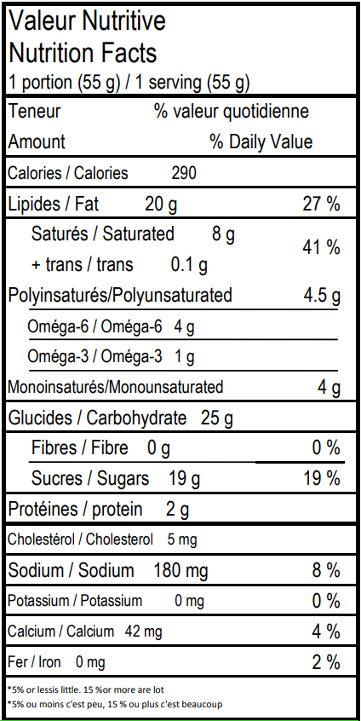

Shelf Life:
10 months frozen 5 days thawed if refrigerated.

